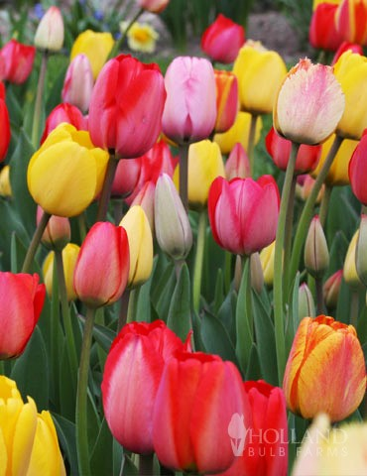

**Easter Flowers**

It is a tradition to decorate our Sanctuary with potted flowering plants for Easter Sunday. This year, we have chosen to have pink and purple Tulip plants and Daffodil plants. As we have in the past, we will also have the option for “Virtual Plants” as well. We invite you to honor and remember your loved ones while helping to support the needs of our church. The list of donors and dedications will be included in the Easter Sunday bulletin. You will be invited to take your plant(s) home with you after the service, or, if you wish, they will be brought to a homebound member. The price is $10 per 6” pot for both the live and “virtual” plants. **Live plant orders are due by March 30th, “virtual” orders by April 13th.**

**Name:** _______________________________________________  
 (*As you would like it to appear in the Easter bulletin)*

**In memory of** _______________________ ______________________

**In honor of** _______________________ ______________________

**Tulip Plant(s) order:  
_____ Pink _____ Purple = _____ Total Plants**

**Daffodil Plant(s) order: = _____ Total Plants**

**“Virtual” Plant(s) order: = _____ “Virtual” Plants**

**@ $10 per plant x ______ Total Plants = ______ Total Due**

Order forms with payment can be mailed, put in the offering plate, or brought to the Church Hall or Office. Please make checks payable to the Church. If you prefer, you may email the form and send the payment separately.